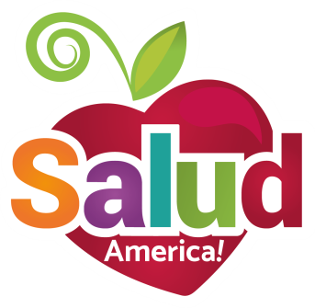
EMAIL TO:
Key Influencer

Dear [PARENTS, PTA, SHAC MEMBERS, SCHOOL STAFF, DEPARTMENT HEADS, ETC.],

Many students in our schools lack consistent access to enough food for healthy and active lives, hurting their development, class performance, and future success.

That’s why we are working to start a School Food Pantry!

A School Food Pantry can accept, store, and distribute donated and leftover unopened food to hungry and food-insecure students, reducing food waste and food insecurity. This is possible due to a 2017 Texas state law (https://salud.to/schoolpantry). And it’s already been done at 10 campuses at San Antonio ISD https://salud.to/SAISDpantries).

Sign up now to support School Food Pantries in our schools:
https://salud.to/pantryletters

Share this handout with parents or other colleagues:
https://salud.to/pantryhandout

We are continuing to work with Salud America!, a Latino health equity research program at the University of Texas Health San Antonio, to build local support and plan and implement a School Food Pantry. Stay tuned for further developments.

Please let me know if you have any questions.

Thank you,
[YOUR NAME, TITLE, CONTACT INFO]

