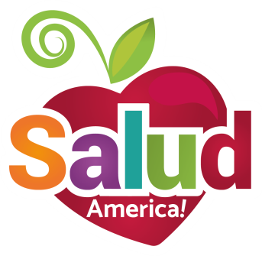
EMAIL TO:
Nutrition Leader

Dear [NAME OF CHILD NUTRITION DIRECTOR/FOOD SERVICES COORDINATOR/ETC.],

We know many students on our campus suffer food insecurity at home and face hunger, hurting their development, school attendance, class performance, and future success.

A School Food Pantry can meet this need!

I am requesting your support in exploring how we can start a School Food Pantry on our campus, taking advantage of two key developments:

- As you know, the Student Fairness in Feeding Act (SB 725) went into effect in Texas in September 2017. This new law enables schools to set up School Food Pantries to accept, store, and distribute donated and leftover food to hungry kids. The law allows districts to: Designate a non-profit representative to receive leftover foods directly from the schools (granola bars, bananas, etc.); redistribute unopened food to students; and reduce food waste. Learn more: https://salud.to/schoolpantry.

- Salud America!, a Latino health equity research program at the University of Texas Health San Antonio, which has developed a free Action Pack with materials to gauge local support and plan and implement a School Food Pantry, as well as technical assistance along the way. Salud America! created the Action Pack based on the successful implementation of School Food Pantries at more than 10 campuses at San Antonio ISD. Learn more: https://salud.to/SAISDpantries.

We are excited about the support that School Food Pantries can provide students in boosting health, attendance, and classroom productivity!

Please let me know if you have any questions.

Thank you,
[YOUR NAME, TITLE, CONTACT INFO]

