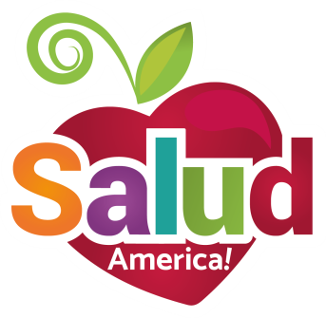
EMAIL TO: Superintendent/Principal

Dear [SUPERINTENDENT NAME / PRINCIPAL NAME],

Many students in our schools live in homes unable to provide enough food for them to live an active, healthy life. In fact, 15.4% of Texans are in this “food insecure” category.

This hurts kids’ development, school attendance, class performance, and future success.

We need School Food Pantries to help these kids!

I am requesting your support so we can engage our campus(es) in starting School Food Pantries across the district, taking advantage of two key developments:
- The Student Fairness in Feeding Act (SB 725) went into effect in Texas in September 2017. This new law enables schools to set up School Food Pantries to accept, store, and distribute donated and leftover food to hungry kids. The law allows districts to: Designate a non-profit representative to receive leftover foods directly from the schools (granola bars, bananas, etc.); redistribute unopened food to students; and reduce food waste. Learn more: https://salud.to/schoolpantry.
- Salud America!, a Latino health equity research program at the University of Texas Health San Antonio, which has developed a free Action Pack with materials to gauge local support and plan and implement a School Food Pantry, as well as technical assistance along the way. Salud America! created the Action Pack based on the successful implementation of School Food Pantries at more than 10 campuses at San Antonio ISD. Learn more: https://salud.to/SAISDpantries.

We are excited about the support that School Food Pantries can provide students in boosting health, attendance, and classroom productivity!

Please let me know if you have any questions.

Thank you,
[YOUR NAME, TITLE, CONTACT INFO]

