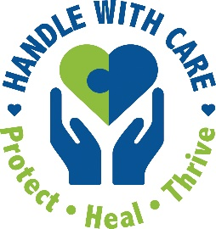
EMAIL TO:
School / Police / Provider

Dear [SCHOOL, POLICE, OR MENTAL HEALTHCARE PERSONNEL],

We know some kids in our city witness to devastating trauma at home and in the community, such as domestic violence, shootings, crime, and accidents.

These kids go to class (virtually or in person) carrying a burden of stress and trauma and can exhibit academic, emotional, or behavioral problems that interfere with learning … but school personnel don’t know and often aren’t prepared to help these kids.

We must start a “Handle With Care” program so we can help these kids!

The Handle With Care program is simple. At the scene of an incident where a child is present, police send a confidential notification─a child’s name, age, school, and a message to “Handle With Care”─to the school. School personnel are prepared to observe and provide trauma-sensitive support as needed, including partnering with mental health professionals. Here is more about Handle With Care, which already is set up in 65+ U.S. cities:
Facts: https://salud.to/hwcfacts & Flow Chart: https://salud.to/hwcflow

I am requesting your support to start a virtual group to plan our Handle With Care program.

Fortunately, we are using a free “Handle With Care Action Pack” to guide us and provide us technical assistance through this process. The Action Pack was created by Salud America!, a Latino health equity research program at the University of Texas Health San Antonio, in collaboration with the creators of the original Handle With Care program.

This is a great opportunity to work together to help all students achieve at their highest levels despite whatever traumatic circumstances they may have endured.

Please let me know I can count on your support as we explore Handle With Care here.

Thank you,
[YOUR NAME, TITLE, CONTACT INFO]

