Build Support by Sharing This Action w/ Local Advocates

Find and Tag Local Advocates on Social Media

Identify the Facebook and Twitter pages of local advocates and community organizations, and tag them in the following social media messages.

Consider generating social media messages based on inequities and disparities on health outcomes specific to your city/county. You can find this information in your community health needs assessment, or by downloading a Health Equity Report Card for your county. In the Report Card, you’ll visually see local maps, gauges, and data that reveal the very inequities that are driving health disparities in your community. Data cover housing, transportation, education, food, environmental issues, socioeconomic status, and more.

Model Social Media Messages (for Customizing)

Our city needs a resolution to declare racism a public health crisis and commit to action!

Racism is a public health crisis. It’s time to dismantle racism in [CITY/COUNTY], starting with a resolution to declare racism a public health crisis and commit to action.

Racism operates on systemic, institutional, and interpersonal levels, all of which operate throughout time and across generations. It’s time to dismantle racism in [CITY/COUNTY], starting with a resolution to declare racism a public health crisis.

Health and racism are inextricably linked, harming individuals and communities of color, including unequal access to quality education, livable wages, healthy food, affordable housing, and safe transportation options. Racism is a public health crisis.

Blacks, Latinos, and other people of color face disparities in social and economic outcomes because systemic racial injustices created opportunity for some and barriers for others.
Our city needs to eradicate implicit and explicit racial bias.

On average, white households have nearly 7x the wealth of black families and 5x the wealth of Latino families. Disparities in economic security are rooted in systemic racial injustices and connected to worse health outcomes. This makes racism is a public health crisis.

Decades of racist housing and highway policies have resulted in low-income renters facing higher housing- and transportation-cost burdens than middle-income renters, but fewer opportunities, thus worse child development and health and reduced earnings as adults.

Historical racism continues to negatively impact educational achievement for Black and Latino residents, who are more likely to live in areas with underperforming school systems. Racism is a public health crisis.

Police brutality and murders against U.S. Black citizens have contributed to systemic inequities and individual burdens that worsen health. Racism is a public health crisis.

Racism is a risk factor for toxic stress, a root cause of some of the most harmful, persistent and expensive health challenges facing our nation. Racism is a public health crisis.

The cumulative experience of racism throughout one's life can induce chronic stress and increase susceptibility to chronic health conditions that lead to otherwise preventable deaths. Racism is a public health crisis.

For far too long, racist policies, regulations, and laws have created inequitable communities that are disproportionately burdened by injury, disease, and premature death. [CITY/COUNTY] is not immune. Racism is a public health crisis here, too.

It’s time to call on [CITY/COUNTY] officials to declare racism to be a public health crisis and commit to action to dismantle it.

[CITY/COUNTY] should take specific actions to dismantle racism, such as recognizing it is a public health crisis and ensuring racially and economically mixed neighborhoods through land-use planning, zoning ordinances, and housing regulations.

[CITY/COUNTY] should take specific actions to dismantle racism, such as recognizing it is a public health crisis and reviewing policies and procedures to both eradicate implicit and explicit racial bias and to build racial equity.

[CITY/COUNTY] should take specific actions to dismantle racism, such as recognizing it is a public health crisis and preventing biased policy decision-making and implementation across various departments and agencies, such as housing, transportation, and law enforcement.

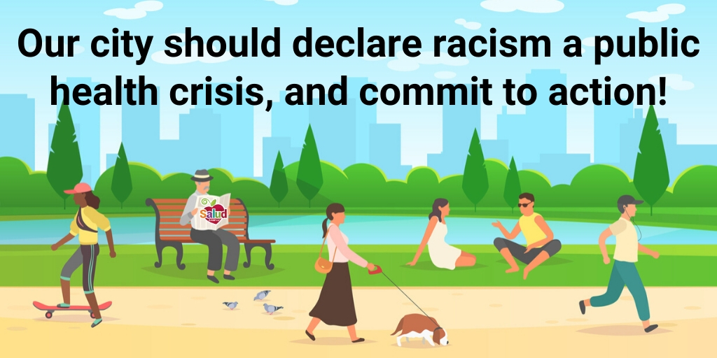
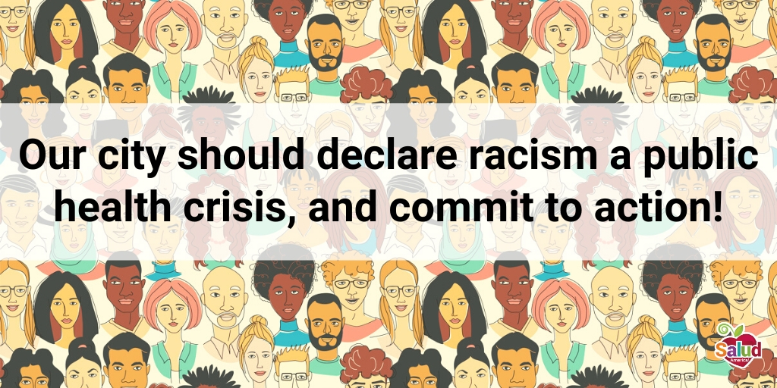
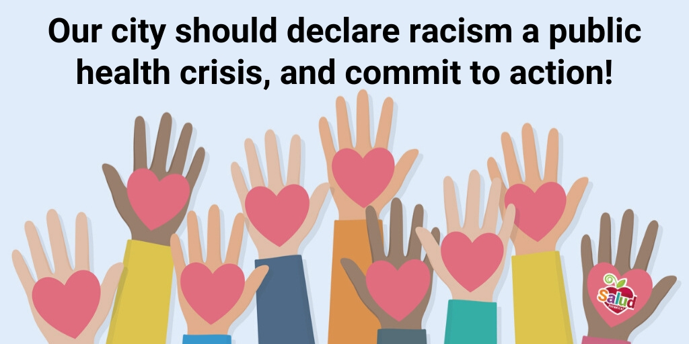
Model Social Media Images

