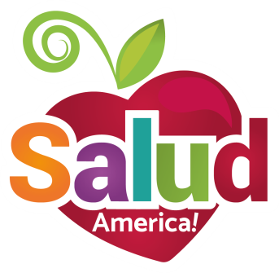

**Share Your Action**

**With Friends, Family!**

**Encourage others to learn about implicit bias**

We hope you’ve learned a little bit about yourself by taking the implicit association test (IAT) at least once, if not several times, and using the Kirwan Institute’s fact sheet to help review and think closely about your IAT results.

We also hope you were able to check out *Salud America!* Salud Heroes who have identified their bias, made a change, and worked to make others more aware of the issue of implicit bias.

We hope you will encourage your friends, family, and colleagues to do the same!

**Share these model social media messages**

Hi, friends! Use @SaludAmerica’s new tool to help you uncover “hidden” bias! salud.to/seebias

*Familia*, use @SaludAmerica’s new tool to help you uncover “hidden” bias! salud.to/seebias

I learned I do have implicit bias. Now I am learning to rewire my understanding, actions, and decisions about other people. You can, too: salud.to/seebias

I didn’t think I had implicit bias. But I do. So I learned from people like me who are intentionally overcoming their bias and switching to compassion. You can, too: salud.to/seebias

When I found out I had implicit bias against certain groups, I learned from people like me who have overcome their bias toward more compassion. You can, too: salud.to/seebias

Implicit bias matters to me. See if you have it: salud.to/seebias

**Share these model messages with these images**

